**Experiment no - 3**

3a Check the browser and website certificate and analyse the certificate

Step 1:- Open Firefox browser and click on manage more settings

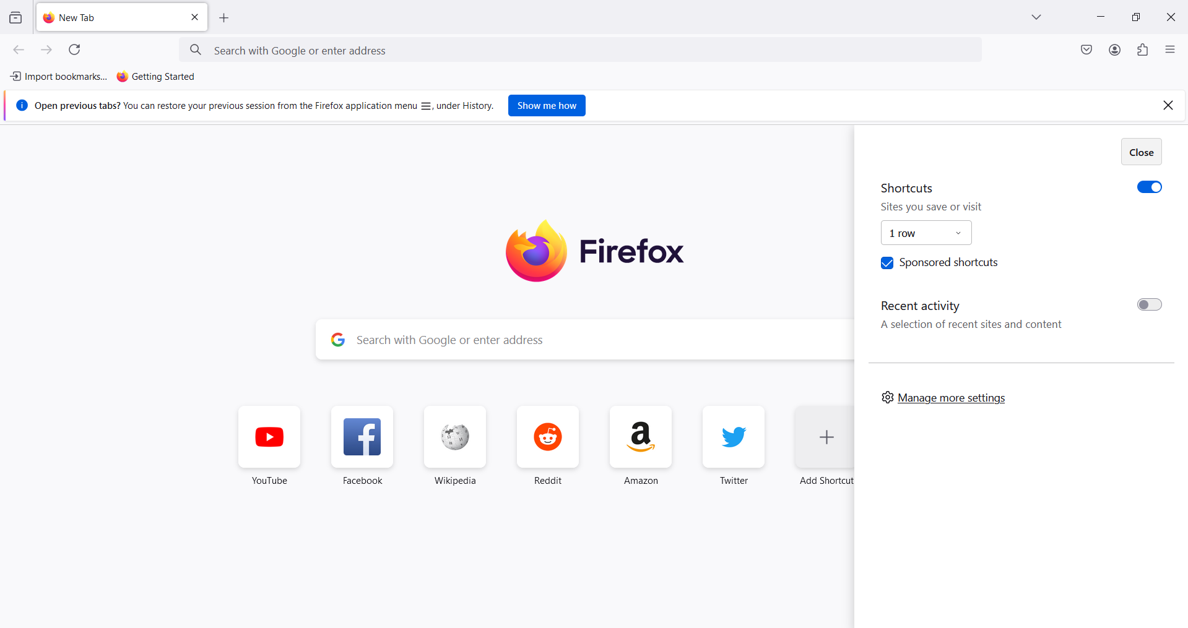

Step 2:- Search certificates in search bax

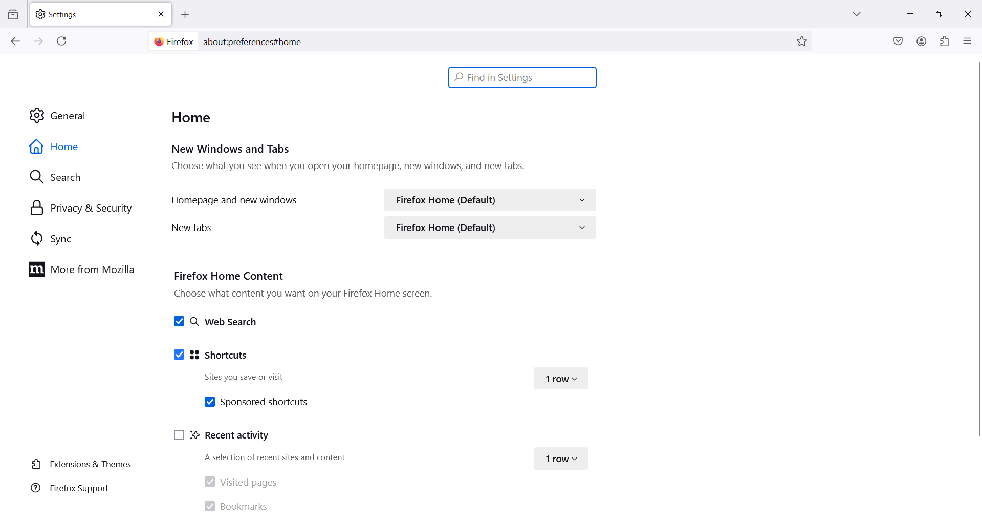

Step 3:- Click on view certificates

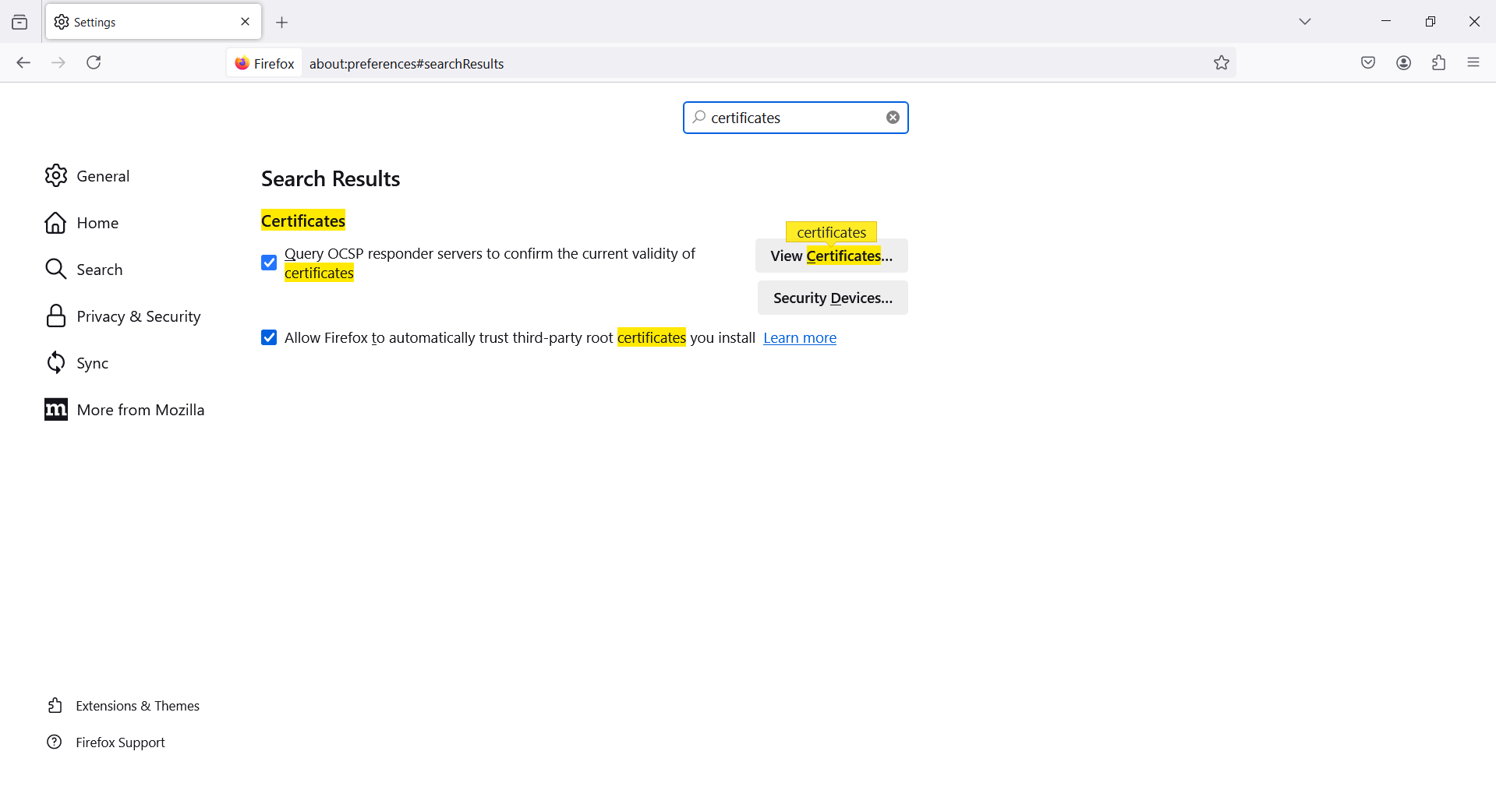

Step 4:-Select anyone certificate and click view

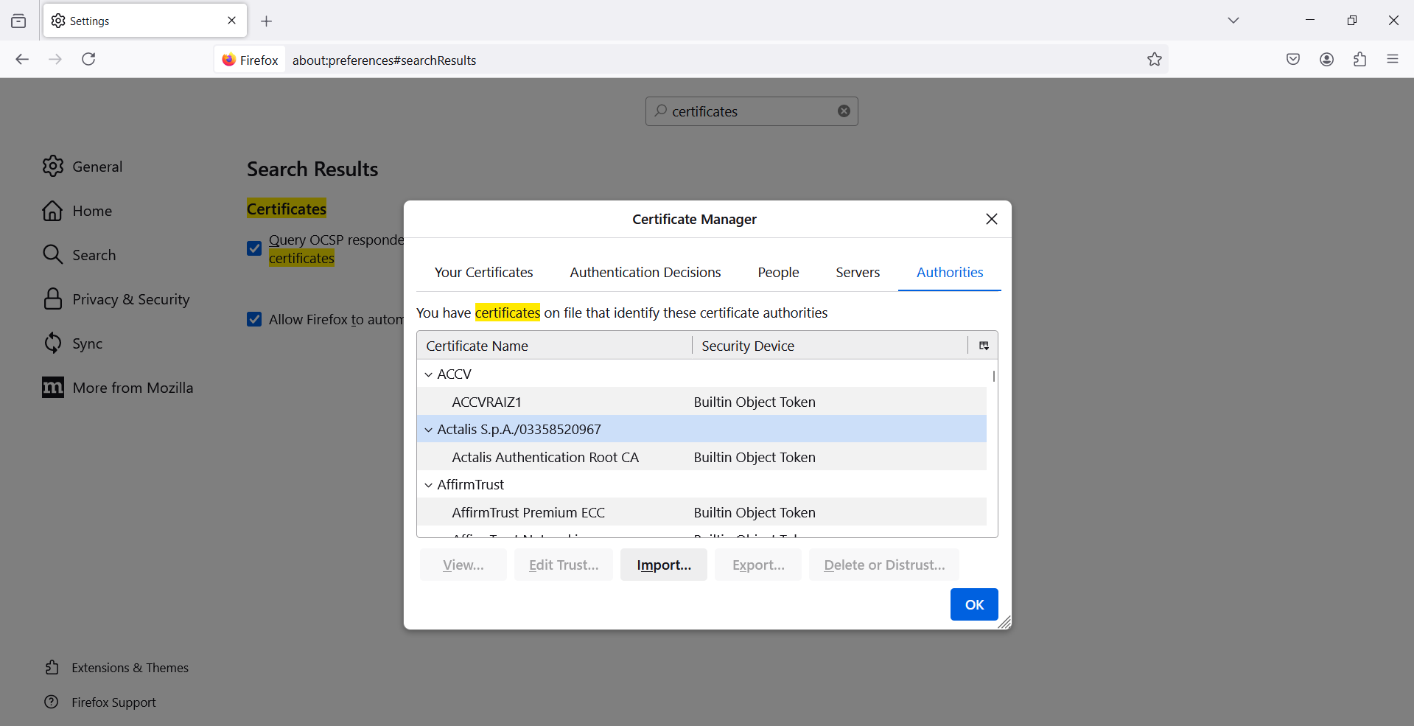

Step 5:- You can see the certificate has they appeared

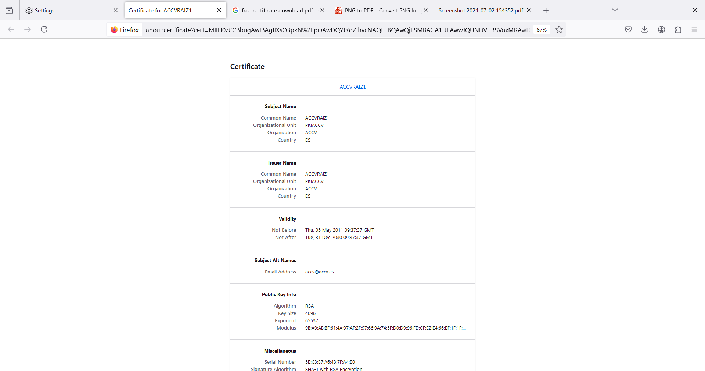

1b Website certificate check

Step 1:- Go to Firefox and search any website

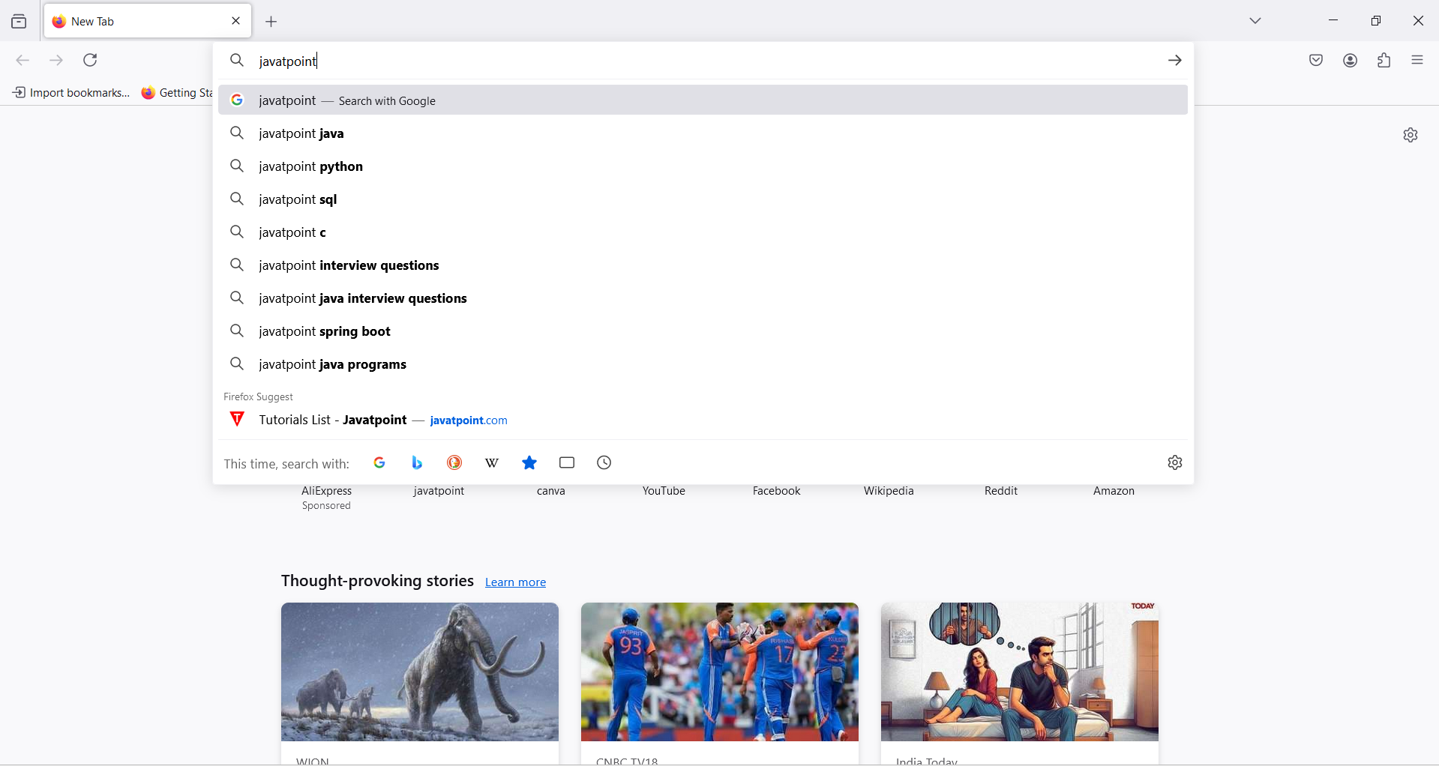

Step 2:- Click lock icon on left side top corner and click on connection secure

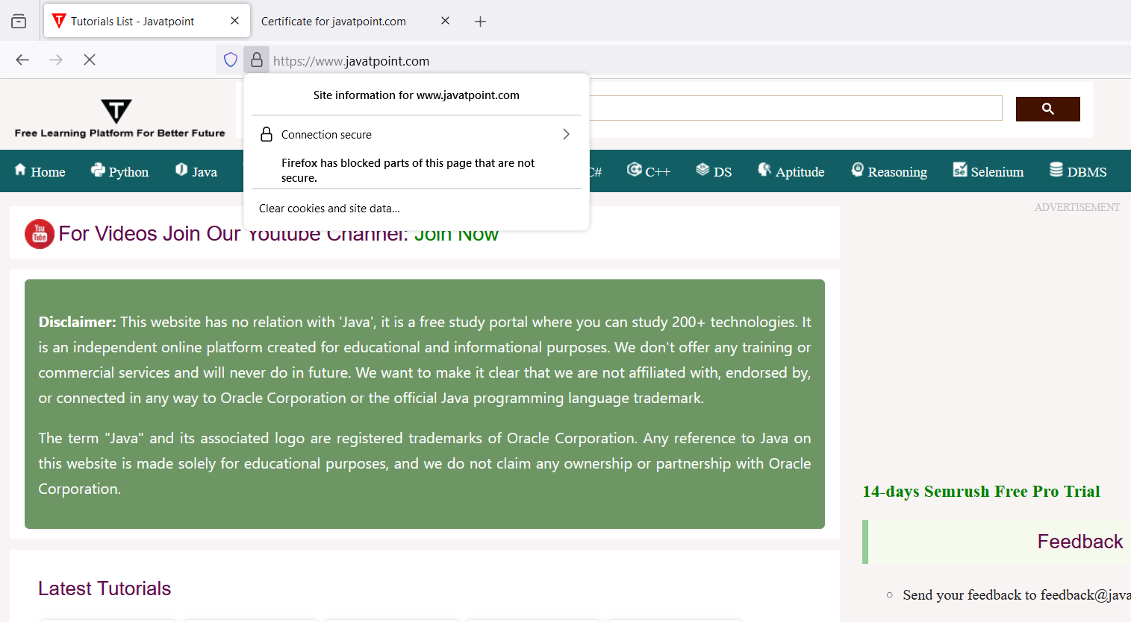

Step 3:-Click on more information

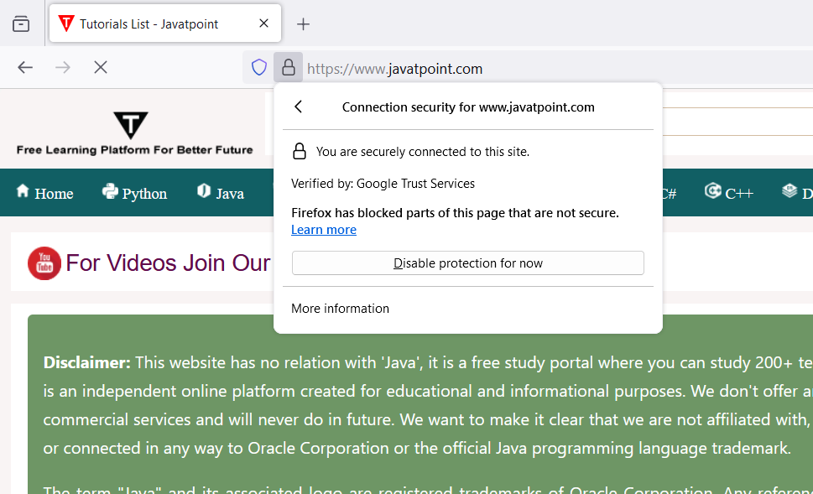

Step4 :-Now click view certificate

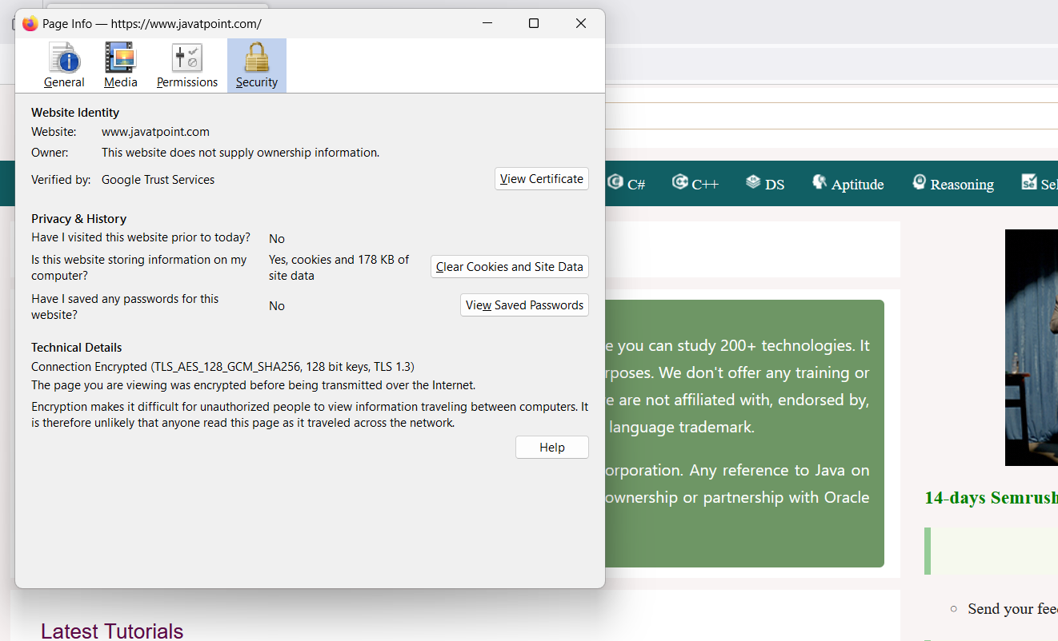

Step 5:- You can see the certificate Details

